# Program on HTML basic tags for text formatting

## Problem Statement

Create a webpage demonstrating various text formatting tags like <b>, <i>, <u>, <strong>, <em>, and <mark>. Apply different tags to show their effects on text.

## Steps to Solve

1. Open your code editor and create a new HTML/PHP/JS file as required.

2. Write the necessary code based on the problem statement.

3. Test the code in a web browser or PHP server to ensure it works as expected.

4. Debug any issues encountered during testing.

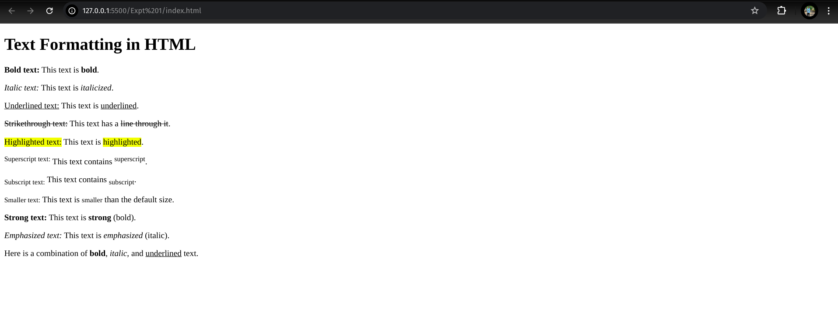5. Submit the code along with proper comments and documentation.